CTD Risk Factor Assessment Form

Check box if Baseline Report
Check box if Follow-up Report

BWC Policy Number __________________ Company: __________________________

Task Title: __________________________

Name of Analyst:_____________________ Evaluation Date: _____________________

Brief Task Description: _________________________________________________________________
__________________________________________________________________________________________________________________________________________________________________________

Amount of time per day task is performed by one person:__________________________

Upper Extremity
A | B |  | C | D | E | F
Risk Factor  Category | Risk  Factors |  | Up to 4 Hours | 4+ to 8 Hours | 8+ Hours  Add 0.5 per hour | Score
Repetition (Finger, Wrist, Elbow, Shoulder, or Neck Motions) | 1. Identical or Similar Motions Performed Every Few Seconds  Motions or motion patterns that are repeated every 15 seconds or less. (Keyboard use is scored below as a separate risk factor.) |  | 1 | 3
 | 2. Intensive Keying  Scored separately from other repetitive tasks in the repetition category; includes steady pace, as in data entry. |  | 1 | 3
 | 3. Intermittent Keying  Scored separately from other repetitive tasks. Keyboard or other input activity is regularly alternated with other activities for 50 to 75 percent of the work. |  | 0 | 1
Hand Force  (Repetitive or Static) | 1. Grip More Than 10-Pound Load  Holding an object weighing more than 10 pounds or squeezing hard with hand in a power grip. | 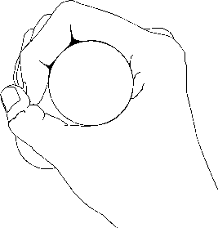 | 1 | 3
 | 2. Pinch More Than 2 Pounds  Pinch force of 2+ pounds as in the pinch used to open a small binder clip with the tips of fingers. | 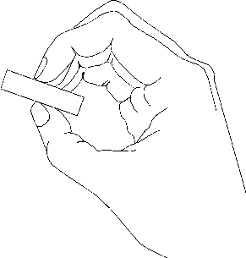 | 2 | 3

Upper Extremity
A | B |  |  |  | C | D | E | F
Risk Factor  Category | Risk  Factors |  |  |  | Up to 4 Hours | 4+ to 8 Hours | 8+ Hours  Add 0.5 per hour | Score
Awkward Postures | 1. Neck: Twist / Bend  Twisting neck to either side more that 20°, bending neck forward more than 20° as in viewing a monitor, or bending neck backward more than 5°. |  | 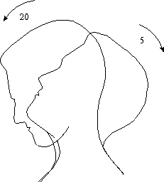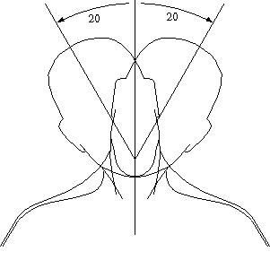 |  | 1 | 2
 | 2. Shoulder: Unsupported Arm or Elbow Above Mid-Torso Height  Arm is unsupported if there is not an arm rest when doing precision finger work, or when the elbow is above mid-torso height. |  |  | 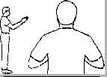 | 2 | 3
 | 3. Forearm: Rapid Rotation  Rotating the forearm or resisting rotation from a tool. An example of forearm rotation is using a manual screwdriver. |  |  |  | 1 | 2
 | 4. Wrist: Bend / Deviate  Wrist bends that involve more than 20° of flexion (bending the wrist palm down) or more than 30° of extension (bending the wrist back). Bending can occur during manual assembly and data entry. |  |  |  | 2 | 3
 | 5. Fingers  Forceful gripping to control or hold an object, such as click-and-drag operations with a computer mouse or deboning with a knife. |  |  |  | 0 | 1
 | 6. Extended arm reaches |  |  |  | 1 | 2
 | 7. Reaching overhead (above shoulder level) |  |  |  | 1 | 2
 | 8. Reaching behind the torso |  |  |  | 1 | 2
Contact Stress | 1. Hard/Sharp Objects Press Into Skin  Includes contact of the palm, fingers, wrist, elbow, or armpit. |  |  |  | 1 | 2
 | 2. Using the Palm of the Hand as a Hammer |  |  |  | 2 | 3
Vibration | 1. Localized Vibration  Vibration from contact between the hand and a vibrating object, such as a power tool. | 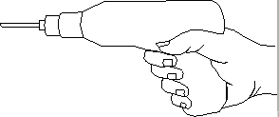 |  |  | 1 | 2

Total Upper Extremity Score:

Back and Legs
A | B |  |  | C | D | E | F
Risk Factor  Category | Risk  Factors |  |  | Up to 4 Hours | 4+ to 8 Hours | 8+ Hours  Add 0.5 per hour | Score
Awkward Postures (Repetitive or Static) | 1. Mild Forward or Lateral Bending of Torso More Than 20° But Less Than 45° | 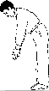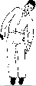 |  | 1 | 2
 | 2. Severe Forward Bending of Torso More Than 45° |  |  | 2 | 3
 | 3. Backward Bending of Torso |  |  | 1 | 2
 | 4. Twisting Torso |  |  | 2 | 3
 | 5. Prolonged Sitting Without Adequate Back Support  Back is not firmly supported by a back rest for an extended period |  |  | 1 | 2
 | 6. Standing Stationary or Inadequate Foot Support While Seated  Stand in one place (an assembly line or check stand) without sit/stand option or walking, or feet are not firmly supported when sitting. |  |  | 0 | 1
 | 7. Kneeling / Squatting |  |  | 2 | 3
 | 8. Repetitive Ankle Extension / Flexion  Using a foot pedal to start or stop a machine cycling (as in sewing machine operations). |  |  | 1 | 2
Contact Stress | 1. Hard / Sharp Objects Press into Skin  Includes contact against the leg. |  |  | 1 | 2
 | 2. Using the Knee as a Hammer or Kicker |  |  | 2 | 3
Vibration | 1. Sitting/Standing on Vibrating Surface (Without Vibration Dampening) |  | 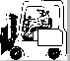 | 1 | 2
Push/Pull | 1. Moderate Load  Force needed to push / pull a shopping cart full of apples. |  |  | 1 | 2
 | 2. Heavy Load  Force need to push / pull a two-drawer, full file cabinet across a carpeted room. |  |  | 2 | 3

Back and Legs (continued)
A | B |  | C | D | E | F
Risk Factor  Category | Risk  Factors |  | Up to 4 Hours | 4+ to 8 Hours | 8+ Hours  Add 0.5 per hour | Score
Manual Materials Handling -Load | 1. Weight  Load being handled is more than 20 pounds. (Write actual weight of maximum load in box to right.) | Actual Weight (lbs.)  _________________ | 2 | 3
 | 2. Distance  Horizontal distance from the mid-point between the ankles to center of the hand is greater than 10 inches. (Write actual maximum distance in box to right.) | Actual Distance (in.)  _________________ | 2 | 3
Manual Materials Handling -Frequency | 1. Lifting Frequency  Lifting frequency is between 1 and 5 times per minute. (Write actual lifting frequency in the box to right.) | Lifting Frequency  _________________ | 1 | 1
 | 2. Lifting Frequency  Lifting frequency is 5 or more times per minute. |  | 2 | 3
TOTAL BACK AND LEGS SCORE:

Environmental Worksheet
A | B |  | C | D | E | F
Risk Factor  Category | Risk  Factors |  | 2 to 4 Hours | 4+ to 8 Hours | 8+ Hours  Add 0.5 per hour | Score
Environ-ment | 1. Lighting (Poor Illumination / Glare)  Inability to see clearly (e.g. glare on a computer monitor). |  | 0 | 1
 | 2. Cold Temperature  Air temperature less than 60ºF for sedentary work, 40ºF for light work, 20ºF for moderate/heavy work; cold exhaust blowing on hands. |  | 0 | 1
TOTAL ENVIRONMENTAL SCORE:
Total Score:
(Upper Extremity + Back and Legs + Environmental)

